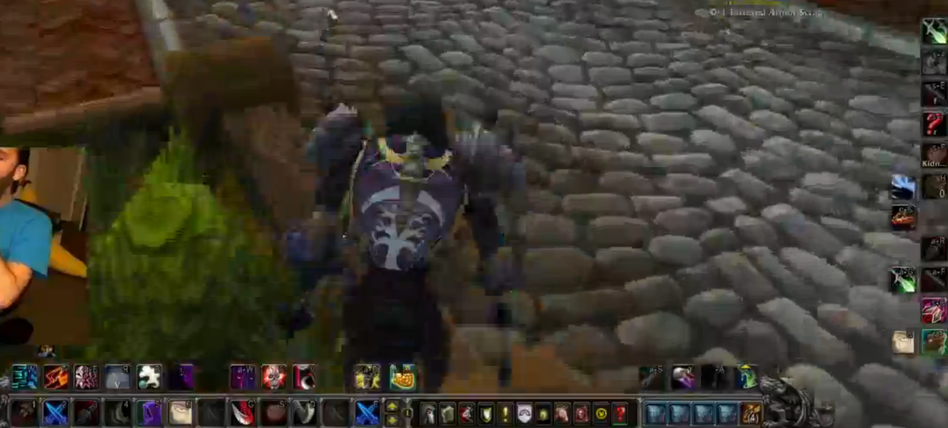

 cheap shot -> mutilate -> shadow reflection -> vendetta -> rupture -> marked for death -> envenom -> vanish -> garrote -> envenom -> mutilate -> mutilate -> envenom

 /castsequence reset=0.9 Burst of Speed, Pick Pocket, Pick Pocket, Pick Pocket